CSS BRITISH HISTORY · TOPIC 4 · KNOWLEDGE BASE
The Industrial and Agricultural Revolutions and the New Society (c.1750–1900)
How farming and industry changed, what it did to people, and the new movements and ideas it produced — Methodism, Chartism, Liberalism, Utilitarianism, Socialism and Fabianism

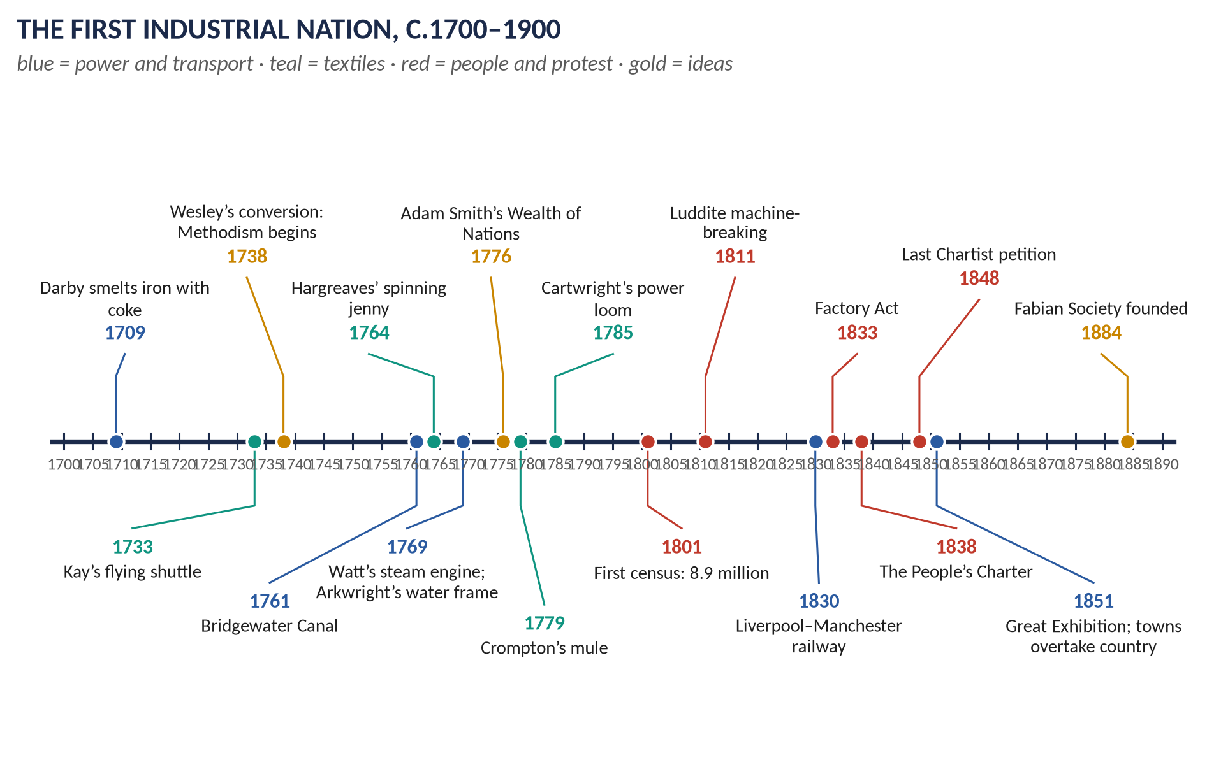
Syllabus head VII. The most-asked topic by number of items: 14 in 2015–2026 — the Industrial Revolution 5 times, Methodism 4, Chartism 2, the ideas 3. Told from zero in simple words, then broken into seven chapters, with 120 one-liners and a stand-alone revision sheet.
Topic 4 of 10 · read with the companion document T4QA
Contents
HOW TO USE THIS · Updating the contents
Right-click the contents → Update Field → Update entire table, before saving as PDF.

How to Use This Document 6
What this Topic covers 6
Part Zero — The ABC Before the Story 7
0.1 Britain before industry — a picture of about 1750 7
0.2 What "revolution" means here 7
0.3 The words you need 7
Part One — The Story 9
1.1 The farms change first 9
1.2 Machines, steam and factories 10
1.3 Canals and railways 10
1.4 The new towns and the new people 11
1.5 Protest and reform 12
1.6 New beliefs and new ideas 12
Part Two — The Cast and the Time-line 13
2.1 The cast 13
2.2 The time-line 14
Part Three — The Chapters 15
Chapter 1 · The Agricultural Revolution 16
1.1 The old way: open fields 16
1.2 What changed 16
(i) Enclosure 16
(ii) New crops and rotations 16
(iii) New tools and breeding 16
(iv) Spreading the ideas 16
1.3 The results 17
Chapter 2 · The Causes of the Industrial Revolution 18
2.1 People 18
2.2 Money and trade 18
2.3 Resources and transport 18
2.4 Ideas, inventions and government 19
2.5 Weighing the causes 19
Chapter 3 · The Effects of the Industrial Revolution 20
3.1 Economic effects 20
3.2 Social effects 20
(i) Towns 20
(ii) Work and family 20
(iii) Reform 21
3.3 Political effects 21
3.4 Cultural effects 21
3.5 The standard-of-living debate 22
3.6 Disruption or progress? — the regional picture 22
Chapter 4 · The Methodist Movement 23
4.1 Why a new religious movement? 23
4.2 How it began 23
4.3 Its salient features 23
(i) Beliefs 23
(ii) Organisation 23
(iii) Worship 24
4.4 Why it succeeded 24
4.5 Its effects — good and bad 24
4.6 Did Methodism save England from revolution? 24
Chapter 5 · Chartism 26
5.1 What Chartism was 26
5.2 Why millions supported it 26
(i) Political anger 26
(ii) The New Poor Law (1834) 26
(iii) Hunger and unemployment 27
(iv) Factory and union grievances 27
(v) Organisation and leaders 27
5.3 The three petitions 27
5.4 Moral force and physical force 27
5.5 Why Chartism failed 27
5.6 Did it really fail? 28
Chapter 6 · The Ideas: Liberalism, Utilitarianism, Socialism, Fabianism 29
6.1 Liberalism 29
6.2 Utilitarianism 29
6.3 Socialism 30
6.4 Fabianism 30
6.5 Socialism and Liberalism compared 31
Chapter 7 · Colonisation and Emigration 32
Part Four — Historians and Quotations 33
Part Five — The Examiner's Record 34
Part Six — The One-Liner Bank 36
One-liners · The Agricultural Revolution 36
One-liners · Causes and inventions 36
One-liners · Effects 37
One-liners · Methodism 38
One-liners · Chartism 39
One-liners · The ideas 40
Part Seven — Revision Sheet · Topic 4: The Industrial and Agricultural Revolutions and the New Society 41
R4.1 The change in one paragraph 41
R4.2 The Agricultural Revolution 41
R4.3 Why Britain industrialised first 41
R4.4 The effects — the four boxes 41
R4.5 Disruption or progress? — regional examples 42
R4.6 Methodism 42
R4.7 Chartism (1838–48) 42
R4.8 The ideas 43
R4.9 Dates to write in every answer 43

How to Use This Document

What this Topic covers
Topic 4 is different from the others. It is not one period of politics but one great change that ran from about 1750 to 1900: the change from a country of farms and villages to the first industrial country in the world. It covers syllabus Head VII: the Industrial and Agricultural Revolutions — their causes, their effects on political and social life — and the movements and ideas they produced: Methodism, Chartism, Liberalism, Socialism, colonisation and party politics. It also covers Utilitarianism and Fabianism, which the examiner has set as short notes.
WHAT THE EXAMINER HAS ASKED · Why this topic matters
14 items in 2015–2026 — more than any other topic. The Industrial Revolution (2015 sn, 2017, 2018, 2019, 2026), Methodism (2015 twice, 2024, 2025 sn), Chartism (2017, 2024), and the ideas (Fabianism 2016 sn, Utilitarianism 2022 sn, Socialism v Liberalism 2025). Every one is answered in T4QA.

THE STORY IN SIMPLE WORDS · Where this topic fits in the story
Topics 1–3 were about kings, Parliament and wars. While all that was happening, something quieter but even bigger was going on: the way people grew food, made things and lived was changing. This topic tells that story. It overlaps in time with Topics 2, 3 and 5 — read it as the background to all of them.

Part Zero — The ABC Before the Story

0.1 Britain before industry — a picture of about 1750
- About 6 million people lived in England and Wales. Most lived in villages and worked on the land.
- Things like cloth were made by hand at home: a family would spin wool into thread and weave it into cloth in their cottage. This is called the domestic system or "putting-out" system — a merchant "put out" raw wool to families and collected the finished cloth.
- Power came from people, horses, wind and water. There were no engines.
- Travel was slow: roads were mud in winter, and heavy goods went by river or along the coast.
- Only London was a really big city. Places that later became huge — Manchester, Birmingham, Leeds — were small market towns.

0.2 What "revolution" means here
In Topics 1 and 3, "revolution" meant a sudden political change — a king overthrown. Here it means something different: a deep change in how people live and work, which happened over several generations, not in a few days. The word "Industrial Revolution" was made popular by the historian Arnold Toynbee in lectures of 1881 (published 1884).
KEY IDEA · The one idea to hold on to
Before, most people grew food and made things by hand at home. After, most people lived in towns and worked for wages in factories, mines and workshops, using machines driven by steam. Everything in this topic — the new classes, the new towns, the new religion, the new politics — follows from that one change.

0.3 The words you need
Word | What it means, simply
Domestic system | Making goods (especially cloth) by hand in workers' own homes, for a merchant.
Factory system | Bringing workers and machines together in one building, working set hours for wages.
Enclosure | Dividing the big open village fields and common land into separate fenced farms, owned by individuals.
Common land | Land that all villagers could use — to graze a cow, collect firewood, keep geese.
Crop rotation | Growing different crops in a field in turn each year, so the soil does not become exhausted.
Capital | Money used to start or expand a business — to build a mill or buy machines.
Entrepreneur | A person who starts and runs a business and takes the risk.
Laissez-faire | French for "let it be": the idea that government should not interfere in business.
Working class | People who live by selling their labour for wages.
Middle class | Factory owners, merchants, bankers, doctors, lawyers — people with property or professions but not great landowners.
Trade union | An organisation of workers who join together to bargain for better pay and conditions.
Nonconformist / Dissenter | A Protestant who does not belong to the Church of England — for example Methodists, Baptists, Quakers.
Franchise | The right to vote.
Chartism | The working-class movement (1838–48) for the six points of the People's Charter — above all, the vote.
Ideology | A connected set of ideas about how society should be organised — for example Liberalism or Socialism.

Part One — The Story
THE STORY IN SIMPLE WORDS · The story in simple words
Read this Part first, straight through, like a story. The details and the arguments come in Part Three.

1.1 The farms change first
For hundreds of years English villages farmed in the same way. Around each village were two or three huge open fields, divided into long narrow strips. Each family farmed scattered strips in each field. Every year one field was left empty — fallow — so the soil could rest. The animals of the whole village grazed together on the common. It was fair, but it was not efficient.
In the eighteenth century landowners began to enclose the land — to join the strips into separate, hedged farms that one owner controlled. Most enclosure was done by private Acts of Parliament: about 4,000 of them between 1750 and 1850. At the same time farmers learned new methods. Jethro Tull's seed drill (early 1700s) sowed seeds in neat rows. "Turnip" Townshend popularised growing turnips and clover, which fed animals in winter and put goodness back into the soil — so no field needed to lie fallow (the Norfolk four-course rotation). Robert Bakewell bred bigger sheep and cattle by choosing the best animals to breed from. Thomas Coke of Norfolk and the writer Arthur Young spread the new ideas.
The result was much more food — enough to feed a population that doubled between 1750 and 1820. But the poorest villagers, who had used the common for a cow or firewood, lost that right. Many became landless labourers or left for the towns — exactly the workers the new factories needed.
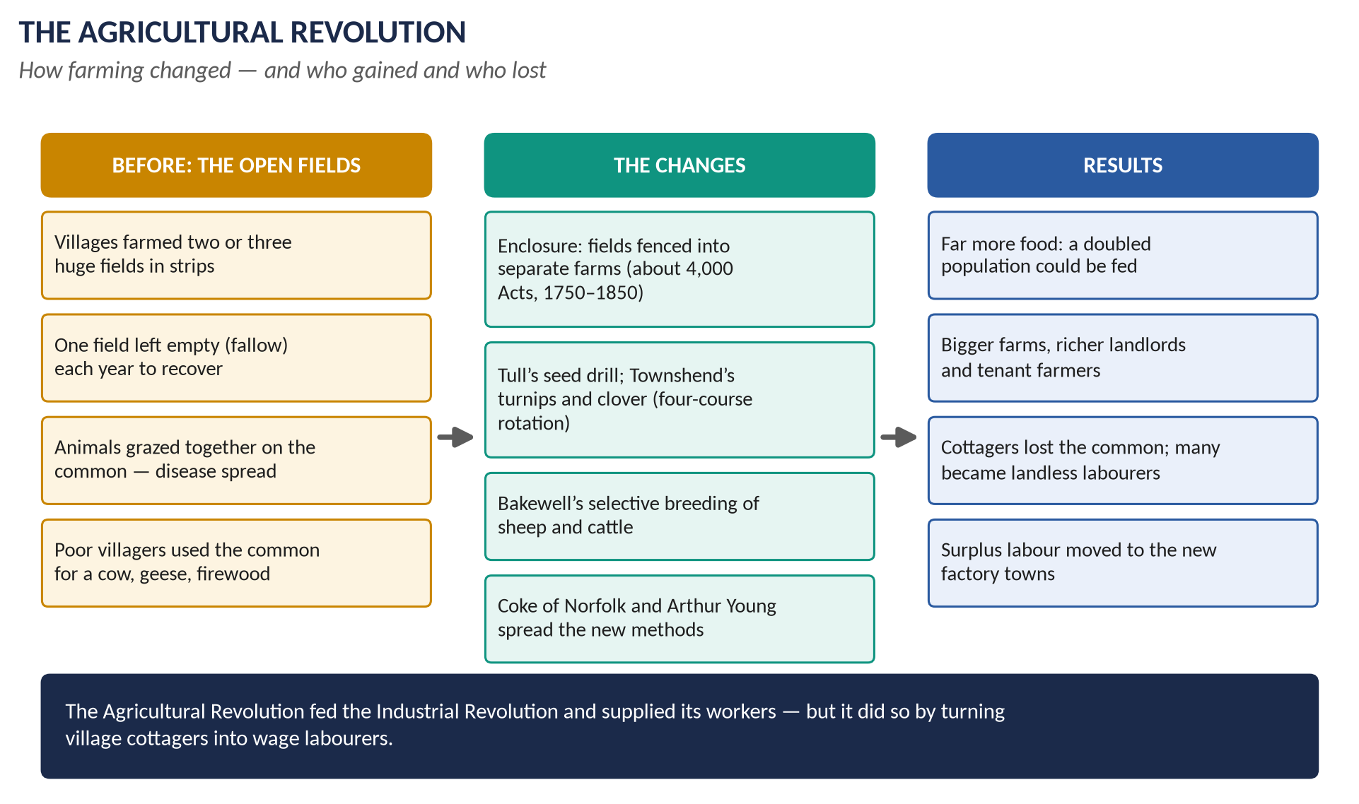
Figure 1 · The Agricultural Revolution: the open fields, what changed, and who gained and who lost.

1.2 Machines, steam and factories
The first industry to change was cotton. A series of inventions made spinning and weaving faster:
- John Kay's flying shuttle (1733) let one weaver weave wider cloth, faster.
- James Hargreaves's spinning jenny (about 1764) spun many threads at once.
- Richard Arkwright's water frame (1769) used water power; in 1771 he built a mill at Cromford — often called the first real factory.
- Samuel Crompton's mule (1779) spun fine, strong thread.
- Edmund Cartwright's power loom (1785) wove by machine.
These machines were too big and costly for a cottage, so work moved into factories — at first beside rivers for water power. Then came steam. James Watt improved the steam engine (patent 1769; with his partner Matthew Boulton from 1775), and by the 1780s his engines could turn machinery. Factories could now be built anywhere there was coal — and they were built in the towns.
Iron and coal grew together. Abraham Darby had learned to smelt iron with coke (made from coal) at Coalbrookdale in 1709; Henry Cort's puddling process (1784) made better iron cheaply. Coal mines went deeper, pumped dry by steam engines.

1.3 Canals and railways
Heavy goods like coal were expensive to move by road. In 1761 the Duke of Bridgewater opened a canal built by James Brindley to carry coal from his mines to Manchester — and the price of coal in Manchester halved. A "canal mania" followed. Then came railways. George Stephenson's engines ran on the Stockton and Darlington Railway (1825), and in 1830 the Liverpool and Manchester Railway — the first to carry passengers and goods by steam on a timetable — opened with Stephenson's Rocket. By 1850 Britain had over 6,000 miles of railway. Goods, people, newspapers and ideas moved faster than ever before.
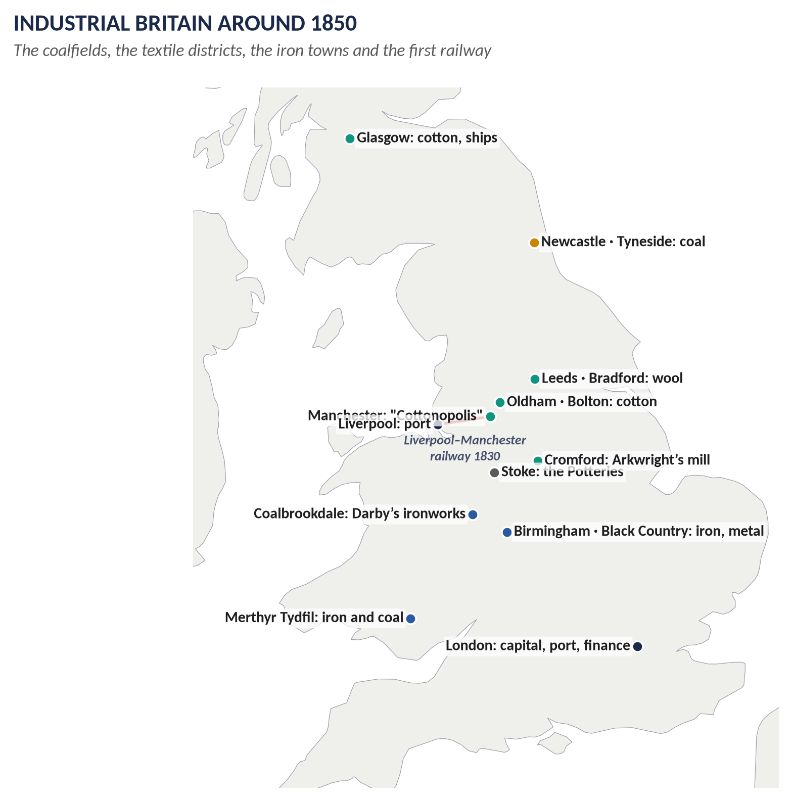
Figure 2 · Industrial Britain around 1850: the regions and their industries.

1.4 The new towns and the new people
People poured into the towns. Manchester, the cotton capital ("Cottonopolis"), grew from about 75,000 people in 1801 to about 300,000 by 1851. The 1851 census showed, for the first time in any large country, that more people lived in towns than in the countryside.
The towns were built fast and badly. Families crowded into back-to-back houses with no running water and shared toilets. Rivers were open sewers. Cholera killed tens of thousands in 1831–32 and 1848–49. In the mills, children as young as five or six worked twelve hours or more a day. The German businessman Friedrich Engels, who lived in Manchester, described it in The Condition of the Working Class in England (1845).
Two new classes took shape. A middle class of factory owners, merchants and professionals grew rich and wanted power to match. A working class of wage-earners had no vote, no protection and — until 1824 — no legal right to form trade unions.

1.5 Protest and reform
The first generation of industrial workers protested. The Luddites (1811–16) smashed the machines that were taking their jobs. Farm labourers burned hayricks in the Swing Riots (1830). Six labourers from Tolpuddle in Dorset were transported to Australia in 1834 for forming a union. Workers joined the struggle for the vote, and when the Reform Act of 1832 gave it to the middle class but not to them, they turned to Chartism (1838–48), the first mass working-class political movement in the world.
Slowly, Parliament began to act. Factory Acts limited children's work (1833) and kept women and children out of mines (1842); the Ten Hours Act (1847) limited working hours; the Public Health Act (1848) began to clean up the towns.

1.6 New beliefs and new ideas
People also looked for new beliefs to make sense of the new world.
- Methodism, begun by John Wesley in 1738, took a warm, simple Christian message to miners, weavers and townspeople whom the Church of England had ignored.
- Liberalism said that freedom and free trade would make everyone richer (Adam Smith, 1776).
- Utilitarianism said every law should be judged by whether it produced "the greatest happiness of the greatest number" (Jeremy Bentham).
- Socialism said the workers who made the wealth should share it, through cooperation rather than competition (Robert Owen).
- Fabianism (1884) said socialism should come slowly and peacefully, through Parliament.
By 1851, when Britain showed off its machines to the world at the Great Exhibition in the Crystal Palace, it was the "workshop of the world" — producing about half the world's iron and cotton cloth.
VERDICT · The story in one sentence
Between 1750 and 1850 better farming fed more people, machines and steam moved work into factories and people into towns, and this new industrial society — rich, crowded, unequal and restless — produced new religions, new protests and new ideas about how it should be governed.

Part Two — The Cast and the Time-line

2.1 The cast
Person | Dates | Who they were — in one line
Jethro Tull | 1674–1741 | Invented the seed drill; wrote Horse-Hoeing Husbandry (1731).
Viscount "Turnip" Townshend | 1674–1738 | Politician who popularised turnips and the four-course rotation.
Robert Bakewell | 1725–95 | Improved sheep and cattle by selective breeding.
Thomas Coke of Norfolk | 1754–1842 | Model farmer at Holkham who spread new methods.
Arthur Young | 1741–1820 | Writer on farming; secretary of the Board of Agriculture (1793).
Abraham Darby | 1678–1717 | Smelted iron with coke at Coalbrookdale (1709).
John Kay | 1704–c.1779 | Flying shuttle (1733).
James Hargreaves | c.1720–78 | Spinning jenny (c.1764).
Richard Arkwright | 1732–92 | Water frame (1769); Cromford Mill (1771); the first great factory owner.
Samuel Crompton | 1753–1827 | Spinning mule (1779).
Edmund Cartwright | 1743–1823 | Power loom (1785).
James Watt | 1736–1819 | Improved the steam engine (1769); partner of Matthew Boulton.
George Stephenson | 1781–1848 | Railway engineer; the Rocket (1829).
John Wesley | 1703–91 | Founder of Methodism.
Charles Wesley | 1707–88 | His brother; wrote over 6,000 hymns.
George Whitefield | 1714–70 | Great open-air preacher of the revival.
Adam Smith | 1723–90 | The Wealth of Nations (1776): free trade and the market.
Jeremy Bentham | 1748–1832 | Founder of Utilitarianism.
John Stuart Mill | 1806–73 | Liberal philosopher: On Liberty (1859), Utilitarianism (1863).
Edwin Chadwick | 1800–90 | Bentham's secretary; shaped the Poor Law (1834) and public health (1848).
Robert Owen | 1771–1858 | Mill owner of New Lanark; father of British socialism.
William Lovett | 1800–77 | Chartist of "moral force"; wrote the Charter.
Feargus O'Connor | 1796–1855 | Chartist of "physical force"; ran the Northern Star.
Friedrich Engels | 1820–95 | Described Manchester's workers (1845); Marx's partner.
Sidney and Beatrice Webb | 1859–1947 / 1858–1943 | Leading Fabians; founded the London School of Economics (1895).
George Bernard Shaw | 1856–1950 | Playwright and Fabian writer.

2.2 The time-line
Figure 3 · The first industrial nation, c.1700–1900.

Part Three — The Chapters

Chapter 1 · The Agricultural Revolution

1.1 The old way: open fields
- Open fields: two or three huge unfenced fields around a village, divided into strips.
- Scattered strips: each family had strips in every field — fair, but much time was lost walking between them.
- Fallow: one field was left empty each year to recover.
- The common: shared grazing and woodland; the poorest families depended on it.
- Problems: little winter feed, so most animals were killed in autumn; animals bred at random; diseases spread in shared herds; no one could improve their land alone.

1.2 What changed

(i) Enclosure
- What: open fields and commons divided into separate, hedged farms owned by individuals.
- How: usually by a private Act of Parliament, which needed the agreement of the owners of most of the land — not most of the people. About 4,000 Acts between 1750 and 1850 enclosed some 6 million acres; the General Enclosure Acts of 1801 and 1845 made the process easier.
- Why: enclosed farms could use new methods; landlords could charge higher rents; high grain prices in the French wars made it very profitable.

(ii) New crops and rotations
- Turnips and clover fed animals through the winter and restored nitrogen to the soil.
- The Norfolk four-course rotation — wheat, turnips, barley, clover — meant no field lay fallow.

(iii) New tools and breeding
- Jethro Tull's seed drill sowed seeds in rows at the right depth — less waste, easier weeding.
- Robert Bakewell bred the best animals together: the New Leicester sheep grew fat quickly for meat.

(iv) Spreading the ideas
Thomas Coke at Holkham held "sheep-shearings" where farmers came to learn; Arthur Young travelled and wrote about best practice; the Board of Agriculture was set up in 1793.

1.3 The results
For | Against
Much more food: Britain fed a doubled population | The poorest lost the common — their cow, geese and firewood
Better, cheaper meat and bread | Many cottagers became landless labourers, dependent on wages
Richer landlords and tenant farmers; capital for industry | Enclosure decided by the powerful, not the majority
Spare workers for the factories | Rural poverty; the Swing Riots (1830)

KEY IDEA · Why it matters for the Industrial Revolution
The Agricultural Revolution fed the towns, freed workers to go into factories, and gave landowners profits they could invest in canals, mines and railways. The two revolutions were two parts of one change.

WHAT THE EXAMINER HAS ASKED · Where it has been asked
Inside 2018 Q3 ("two movements, Agrarian and Industrial"). The Agricultural Revolution on its own has never been set — a likely surprise.

Chapter 2 · The Causes of the Industrial Revolution
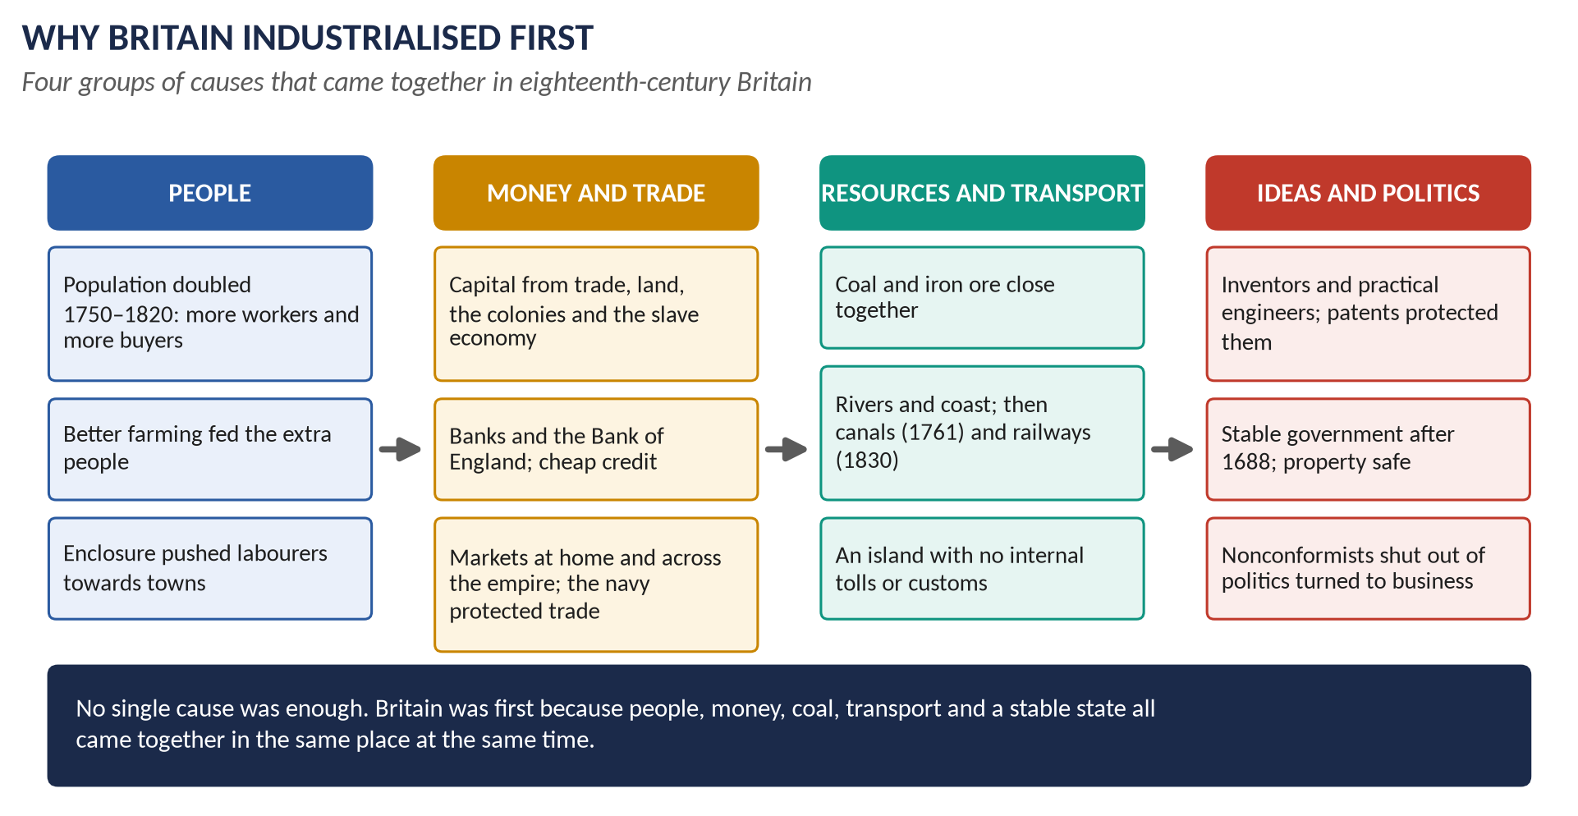
Figure 4 · Why Britain industrialised first: four groups of causes.

2.1 People
- Population growth: England and Wales grew from about 6 million (1750) to 8.9 million (first census, 1801) to 17.9 million (1851). More people meant more workers and more buyers.
- Why it grew: people married younger and had more children; fewer died of famine because food supplies improved.

2.2 Money and trade
- Capital: wealth from farming, from overseas trade, from the colonies and the slave-based sugar economy (the argument of Eric Williams), and from family savings.
- Banks: the Bank of England (1694) and hundreds of country banks lent money to businesses.
- Markets: a large home market, and a world market protected by the Royal Navy and the empire.

2.3 Resources and transport
- Coal and iron ore were found close together, often near rivers or the coast.
- Transport: no part of Britain is more than about 70 miles from the sea; navigable rivers; turnpike roads; canals from 1761; railways from 1830.
- No internal customs: goods moved freely across Britain (unlike France or Germany with their many tolls).

2.4 Ideas, inventions and government
- Inventors were usually practical men — craftsmen and engineers — who solved real problems.
- Patents protected inventions, so inventors could profit.
- Stable government after 1688: property was safe, the law protected contracts, and Parliament represented landowners and merchants who favoured growth.
- Nonconformists, barred from Parliament and the universities, put their energy into business: many great industrialists were Quakers or Unitarians.

2.5 Weighing the causes
No single cause explains it. Other countries had some of these advantages; Britain had all of them at once. Historians such as Phyllis Deane stress the combination; N. F. R. Crafts argues that growth was slower and more gradual than the word "revolution" suggests — but that by 1850 the change was complete.

Chapter 3 · The Effects of the Industrial Revolution
HOW TO USE THIS · The four areas the examiner always names
2017 and 2019 both asked for the effects on "social, economic, political and cultural life". Learn them in exactly these four boxes.

3.1 Economic effects
- Output: Britain became the "workshop of the world". By 1850 it produced about half the world's iron and cotton cloth.
- Industries: cotton (Lancashire), wool (Yorkshire), iron and metal (the Black Country, South Wales), coal (the North-East, Wales, Scotland), pottery (Wedgwood in Staffordshire), shipbuilding (the Clyde).
- Work: from the domestic system to the factory system — fixed hours, the clock, discipline, wages.
- New classes: the middle class (owners, merchants, professionals) and the working class (wage-earners).
- Trade: free trade became policy — the Corn Laws were repealed in 1846 (Topic 5).
- Winners and losers: factory owners and skilled engineers prospered; handloom weavers were ruined by the power loom.

3.2 Social effects

(i) Towns
- Urbanisation: Manchester about 75,000 (1801) → 300,000 (1851); Birmingham, Leeds, Glasgow and Liverpool grew as fast.
- 1851 census: more people lived in towns than in the countryside.
- Housing: back-to-backs, cellars, no sewers, polluted water.
- Health: cholera (1831–32, 1848–49); typhus; average life expectancy in Manchester in the 1840s was under 30 for working people.

(ii) Work and family
- Child labour: children as young as five or six in mills and mines; long hours; accidents; beatings.
- Women worked in mills and, until 1842, underground in mines.
- The family, once a working unit at home, was split by the factory day.

(iii) Reform
Year | Reform
1802, 1819 | Early Factory Acts (apprentices; cotton mills) — hardly enforced
1833 | Factory Act: no children under 9 in textile mills; ages 9–13 limited to 9 hours a day; inspectors appointed
1834 | New Poor Law: workhouses for the able-bodied poor
1842 | Mines Act: no women or girls, and no boys under 10, underground
1844 | Factory Act: women limited to 12 hours
1847 | Ten Hours Act for women and young people
1848 | Public Health Act: local boards of health (after Chadwick's report of 1842)
1870 | Education Act: schools for all children

3.3 Political effects
- The middle class demanded power: the new towns had no MPs; the Reform Act of 1832 gave them seats and gave middle-class men the vote (Topic 5).
- The working class demanded power: Chartism (1838–48); later the Reform Acts of 1867 and 1884 gave the vote to working men.
- Free trade: the Anti-Corn Law League (1838), led by Richard Cobden and John Bright, won the repeal of the Corn Laws (1846).
- Trade unions: legal from 1824; the "new model unions" of skilled workers (1850s); the TUC (1868); later the Labour Party (1900).
- Party politics: industrial and commercial interests shaped the new Liberal and Conservative parties.
- The state grew: inspectors, boards of health, a civil service — the end of pure laissez-faire.

3.4 Cultural effects
- Religion: Methodism and other Nonconformist chapels spread in industrial areas; Sunday schools taught millions to read.
- Reading and the press: cheap newspapers, spread by rail; Mechanics' Institutes for workers.
- Literature: the "condition of England" novels — Dickens's Hard Times (1854), Elizabeth Gaskell's Mary Barton (1848) and North and South (1855); Disraeli's Sybil (1845) on the "two nations" of rich and poor.
- Time and leisure: factory time, railway time (standardised clocks), seaside holidays by train, organised football later in the century.
- National pride: the Great Exhibition of 1851.

3.5 The standard-of-living debate
View | Argument
Optimists (T. S. Ashton, R. M. Hartwell) | Industry created jobs, cheaper goods and, over time, rising real wages
Pessimists (the Hammonds, E. J. Hobsbawm, E. P. Thompson) | The first generation suffered: long hours, bad housing, child labour, loss of independence
Modern evidence (C. Feinstein) | Real wages barely rose until the 1840s, then rose steadily — so the pessimists are right about the early decades, the optimists about the later ones

3.6 Disruption or progress? — the regional picture
Region | Disruption | Progress
Lancashire (cotton) | Handloom weavers ruined; Manchester slums; Peterloo (1819) | Cotton Britain's biggest export; mill towns grow rich
West Riding of Yorkshire (wool) | Luddites attack mills (1812) | Leeds and Bradford become great manufacturing cities
Midlands (Nottingham, Black Country) | Framework knitters' Luddism (1811); child labour in nail-making | Birmingham the "city of a thousand trades"; rebuilt by Joseph Chamberlain (1870s)
South Wales (iron, coal) | Merthyr Tydfil's squalor; the Merthyr Rising (1831); Newport Rising (1839) | World's largest ironworks at Dowlais; coal exports
North-East (coal) | Dangerous pits; child miners | The railway born at Stockton (1825); Tyneside engineering
Scotland (Glasgow, the Clyde) | Some of the worst slums in Europe | Shipbuilding capital of the world by 1900

WHAT THE EXAMINER HAS ASKED · Where Chapters 2–3 have been asked
2015 short note · 2017 Q3 (effects) · 2018 Q3 (two movements) · 2019 Q4 (causes and effects) · 2026 Q3 (disruption or progress, with regional examples). All answered in T4QA.

Chapter 4 · The Methodist Movement

4.1 Why a new religious movement?
- A tired Church of England: many clergy were comfortable gentlemen who held several parishes (pluralism) and lived away from them (non-residence). Sermons were dry and intellectual.
- Churches in the wrong places: new mining and industrial villages had no church at all.
- A great need: poor, uprooted people facing hard lives, drink and early death wanted comfort and hope.

4.2 How it began
- 1729: at Oxford University, John and Charles Wesley and friends formed the "Holy Club", praying, studying and visiting prisoners by strict rule — so others mocked them as "Methodists".
- 24 May 1738: at a meeting in Aldersgate Street, London, John Wesley felt his "heart strangely warmed" — a personal conversion.
- 1739: shut out of many churches, he followed George Whitefield in preaching in the open air — first to the coal miners of Kingswood near Bristol.
- 1739–91: Wesley travelled about 250,000 miles on horseback and preached about 40,000 sermons.
- 1744: the first Conference of preachers.
- 1784: the Deed of Declaration gave the Conference legal control; Wesley ordained ministers for America.
- 1791: Wesley died, still calling himself a member of the Church of England; the Methodists separated soon after (1795).

4.3 Its salient features

(i) Beliefs
- Salvation is open to everyone, rich or poor — not only to a chosen few.
- A personal experience of God's love, and a changed, holy life afterwards.
- A strict moral code: no drunkenness, gambling, swearing or idleness.

(ii) Organisation
- Classes of about 12 members with a leader, meeting weekly.
- Societies in each town; circuits of travelling preachers.
- Lay preachers: ordinary people, not ordained clergy — even some women.
- The annual Conference governed the whole movement.

(iii) Worship
Warm, emotional services; the hymns of Charles Wesley (over 6,000, such as Love Divine, All Loves Excelling); preaching in fields, market-places and chapels.

4.4 Why it succeeded
1. It went to the people — to the fields, the mines, the new towns — where the Church was absent.
2. Its message was simple and hopeful: everyone matters to God.
3. It gave ordinary people dignity and responsibility — as class leaders and preachers.
4. Its organisation was brilliant and flexible.
5. Wesley's energy and long life (he preached into his eighties).
6. It met the needs of a society uprooted by the Industrial Revolution.
By Wesley's death in 1791 there were about 72,000 Methodists in Britain; by 1850 the various Methodist bodies had several hundred thousand members. The Primitive Methodists (1811) were especially strong among miners and farm labourers.

4.5 Its effects — good and bad
Good effects | Bad effects
Sobriety, thrift, honesty: less drinking, gambling and violence | Taught the poor to accept their condition and obey their masters
Education: Sunday schools taught millions to read | Narrow and puritan: hostile to theatre, dancing, pleasure
Leadership: working men learned to speak, organise and lead — many later led trade unions and Chartism | Emotional excesses at some meetings; divisions after 1791
Social conscience: Wesley attacked slavery (1774); visits to prisoners and the sick | Some saw it as a way for employers to discipline workers

4.6 Did Methodism save England from revolution?
- Élie Halévy (the "Halévy thesis"): Methodism turned discontent into religion and moral discipline, and so helped Britain avoid a French-style revolution.
- E. P. Thompson: it was a form of social control, a "chiliasm of despair" that taught workers obedience.
- But: many union and Chartist leaders were Methodist lay preachers — for example George Loveless, one of the Tolpuddle Martyrs (1834). Methodism taught people how to organise.
WHAT THE EXAMINER HAS ASKED · Where Chapter 4 has been asked
2015 short note and 2015 P2 Q3 (emergence; good and bad effects) · 2024 Q4 (how it began; features; reasons for success) · 2025 short note. MCQ 2025: the religious movement that emphasised personal piety and social reform → Methodism.

Chapter 5 · Chartism

5.1 What Chartism was
The first mass working-class political movement in history (1838–1848), named after the People's Charter — a short document of six demands drawn up in 1838 by William Lovett of the London Working Men's Association (founded 1836).
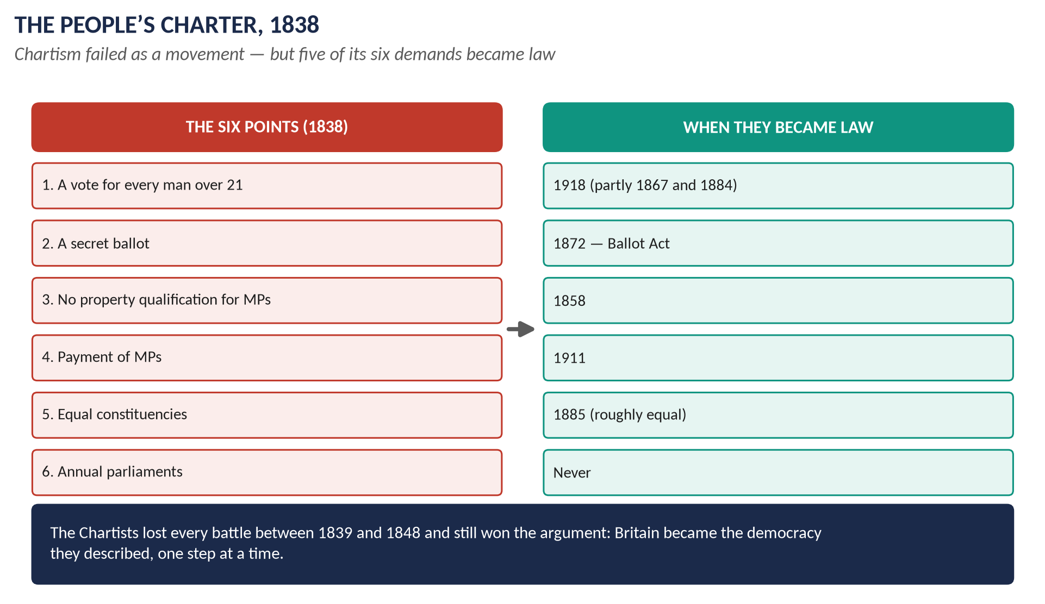
Figure 5 · The six points of the People's Charter, and when each became law.

5.2 Why millions supported it

(i) Political anger
The Reform Act of 1832 gave the vote to middle-class men but not to workers, who had campaigned for it. Workers called it "the great betrayal". Only a Parliament elected by working men, they believed, would pass laws for working men.

(ii) The New Poor Law (1834)
It ended help for the poor in their own homes: the able-bodied poor had to enter a workhouse, where families were split up and conditions made deliberately harsh. The poor called them "Bastilles". The anti-Poor Law movement in the north flowed straight into Chartism.

(iii) Hunger and unemployment
A deep depression hit in 1837–42: factories closed, wages fell, bread was dear because the Corn Laws kept out foreign grain. Handloom weavers were starving. Support for Chartism rose and fell with bad and good times.

(iv) Factory and union grievances
Long hours, child labour, and the punishment of the Tolpuddle Martyrs (1834) for forming a union.

(v) Organisation and leaders
Feargus O'Connor's powerful speeches and his newspaper the Northern Star (1837), which sold up to 50,000 copies a week; mass meetings, torchlight processions; one simple six-point programme.

5.3 The three petitions
Year | Signatures | What happened
1839 | About 1.3 million | Rejected by the Commons (235 to 46). The Newport Rising (November): about 22 killed; the leader John Frost transported
1842 | About 3.3 million | Rejected (287 to 49). The "Plug Plot" strikes across the north
1848 | Claimed 5.7 million; about 2 million real | Great meeting at Kennington Common (10 April); government ready with troops and special constables; petition found to contain fake names ("Victoria Rex", "Mr Punch"); rejected

5.4 Moral force and physical force
- Moral force (Lovett): win by argument, education and peaceful petition.
- Physical force (O'Connor, sometimes; Harney): threaten or use force if Parliament refused.
- The quarrel split the movement and frightened away middle-class sympathy.

5.5 Why Chartism failed
1. Divided leadership and methods — moral v physical force; O'Connor's quarrels; his failed Land Plan.
2. A strong and united state — the army (General Napier in the north), the new police, railways and the telegraph to move troops quickly; the middle class and the aristocracy united against it.
3. Middle-class hostility — after 1832 the middle class had the vote and no wish to share it; many middle-class reformers backed the Anti-Corn Law League instead.
4. Economic recovery — support collapsed whenever times improved (after 1842 and after 1848); the railway boom brought jobs.
5. Reforms took away grievances — the Mines Act (1842), the repeal of the Corn Laws (1846), the Ten Hours Act (1847).
6. Parliament simply refused — and the Chartists had no way to force it without violence, which most would not use.
7. The fake signatures of 1848 made the movement a laughing-stock.

5.6 Did it really fail?
In the short term, yes. In the long term its demands were almost all won: no property qualification for MPs (1858), the secret ballot (1872), roughly equal constituencies (1885), payment of MPs (1911), votes for all men over 21 (1918). Only annual parliaments never came. Chartism also taught working people to organise, and fed into trade unionism, co-operation and, later, the Labour Party.
WHAT THE EXAMINER HAS ASKED · Where Chapter 5 has been asked
2017 Q4 (account; why it failed) · 2024 Q3 (why millions supported it). MCQ 2025: the main demand of the Chartists → universal male suffrage.

Chapter 6 · The Ideas: Liberalism, Utilitarianism, Socialism, Fabianism
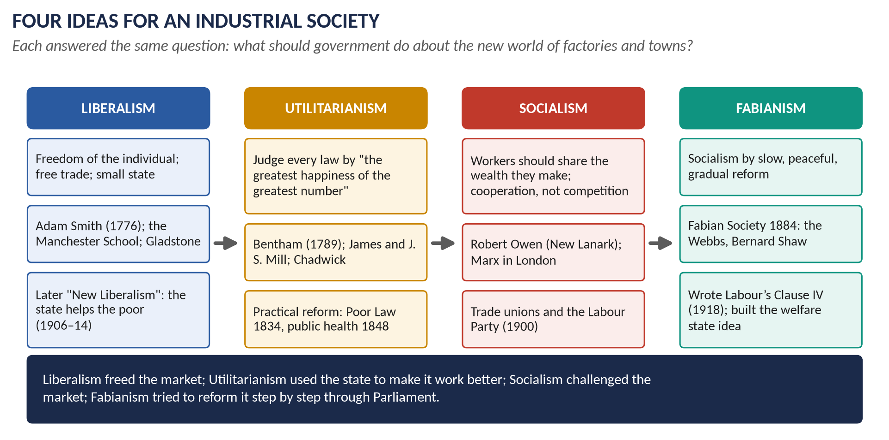
Figure 6 · Four ideas for an industrial society.

6.1 Liberalism
- Core idea: the freedom of the individual. People should be free to think, speak, worship, trade and work as they choose.
- Economics: free trade and laissez-faire — Adam Smith's The Wealth of Nations (1776): each person pursuing their own interest, guided by the "invisible hand" of the market, makes the nation richer. David Ricardo and the Manchester School (Cobden, Bright) continued the argument.
- Politics: limited government, religious freedom, reform of privilege — the Liberal Party of Gladstone (Topic 5).
- Self-help: Samuel Smiles's Self-Help (1859) — success comes from hard work and thrift.
- Change: John Stuart Mill (On Liberty, 1859) and later the "New Liberals" (T. H. Green, L. T. Hobhouse) argued that real freedom needs education, health and security — so the state must help. This led to the Liberal reforms of 1906–14 (Topic 7).

6.2 Utilitarianism
- Founder: Jeremy Bentham (1748–1832), An Introduction to the Principles of Morals and Legislation (1789).
- Core idea: every law and institution should be judged by one test — does it produce "the greatest happiness of the greatest number"? Pleasure is good, pain is bad; laws should increase the first and reduce the second.
- Method: rational, scientific government — inquiry, statistics, inspection. Bentham designed the Panopticon, a prison where one guard could watch everyone.
- Followers: James Mill, John Stuart Mill (Utilitarianism, 1863), the "Philosophic Radicals".
- Influence on reform: Edwin Chadwick, Bentham's secretary, shaped the New Poor Law (1834) and the Public Health Act (1848); Utilitarian ideas influenced law reform, prison reform, the civil service and the Reform Act of 1832.
- Criticism: it could be cold and mechanical — Dickens mocked it in Hard Times (Mr Gradgrind: "Facts alone are wanted in life").

6.3 Socialism
- Core idea: wealth is made by workers, so it should be shared by the community; cooperation should replace competition; land and industry should be owned in common or by the state.
- Robert Owen (1771–1858): at his mills in New Lanark (Scotland) he gave workers decent houses, schools and shorter hours — and still made a profit; later the Grand National Consolidated Trades Union (1834) and the co-operative movement (the Rochdale Pioneers, 1844).
- Christian Socialists (F. D. Maurice, Charles Kingsley, 1848).
- Karl Marx lived in London from 1849 and wrote Capital (1867) in the British Museum: capitalism would be overthrown by revolution.
- Late-century revival: Hyndman's Social Democratic Federation (1881), William Morris's Socialist League (1884), the Fabian Society (1884), Keir Hardie's Independent Labour Party (1893), the Labour Representation Committee (1900).

6.4 Fabianism
- Founded: January 1884 in London.
- Name: from the Roman general Quintus Fabius Maximus, who defeated Hannibal by patience and delay rather than one big battle.
- Leaders: Sidney and Beatrice Webb, George Bernard Shaw, Annie Besant, Graham Wallas; later H. G. Wells.
- Core idea: socialism should come gradually, peacefully and through Parliament — "the inevitability of gradualness" (Sidney Webb) — not by revolution.
- Method: "permeation": research and argument to persuade politicians and civil servants of all parties; the Fabian Essays in Socialism (1889).
- Achievements: helped found the Labour Party (1900); founded the London School of Economics (1895) and the New Statesman (1913); Sidney Webb wrote Labour's Clause IV (1918); Beatrice Webb's Minority Report on the Poor Law (1909) foreshadowed the welfare state.

6.5 Socialism and Liberalism compared
Issue | Liberalism | Socialism
The individual and society | The free individual comes first | The community comes first
Economic inequality | Natural and useful; growth makes everyone better off | Unjust; caused by private ownership; wealth must be shared
Social justice | Equal rights and equal opportunity; self-help | Equal conditions: decent housing, work, education for all
The role of the state | Small: keep order, defend property, free trade (laissez-faire) | Large: the state or community should own, plan and provide
Method of change | Reform through Parliament | Reform (Owen, Fabians) or revolution (Marx)
Key names | Adam Smith, Cobden, Bright, Gladstone, J. S. Mill | Owen, Marx, the Webbs, Keir Hardie
By 1900 | "New Liberalism" accepts state help for the poor | Fabians make socialism gradual and parliamentary

KEY IDEA · The meeting point
The two ideologies began as opposites but moved towards each other: New Liberals accepted that the state must help the poor; Fabians accepted gradual, parliamentary change. The welfare state of the twentieth century grew from their meeting.

WHAT THE EXAMINER HAS ASKED · Where Chapter 6 has been asked
2016 short note (Fabianism) · 2022 short note (Utilitarianism) · 2025 Q5 (Socialism and Liberalism compared).

Chapter 7 · Colonisation and Emigration
The syllabus names "colonisation" under this head. It has never been set, but it belongs here because industrial Britain sent people, money and goods across the world.
- Emigration: between 1815 and 1914 more than 20 million people left the British Isles, mostly for the USA, Canada, Australia, New Zealand and South Africa — pushed by poverty (and, in Ireland, the Famine) and pulled by land and wages.
- Systematic colonisation: Edward Gibbon Wakefield argued (from 1829) that colonial land should be sold at a fair price and the money used to pay the passage of labourers — the model for South Australia (1836) and New Zealand (1840).
- Transportation: convicts were sent to Australia from 1788 (Botany Bay) until 1868.
- Economic empire: industry needed raw materials (cotton from America and India, wool from Australia) and markets; British capital built railways across the world.
- Link to later topics: the settler colonies became the self-governing Dominions and later the heart of the Commonwealth (Topic 8).

Part Four — Historians and Quotations
Historian or writer | The view to quote
Arnold Toynbee, Lectures on the Industrial Revolution (1884) | Made the phrase "Industrial Revolution" famous; saw it as a sudden, painful change.
T. S. Ashton, The Industrial Revolution 1760–1830 (1948) | The optimist: industry lifted living standards.
E. J. Hobsbawm, Industry and Empire (1968) | Britain was first because of its world trade and empire; the workers paid the cost.
E. P. Thompson, The Making of the English Working Class (1963) | The working class "made itself"; Methodism a "chiliasm of despair".
J. L. and Barbara Hammond, The Town Labourer (1917) | The classic pessimist account of suffering.
N. F. R. Crafts (1985) | Growth was slower and more gradual than "revolution" implies.
Élie Halévy (1913) | Methodism saved England from revolution.
Friedrich Engels, The Condition of the Working Class in England (1845) | An eyewitness account of Manchester's slums.
Benjamin Disraeli, Sybil (1845) | Britain was "two nations" — the rich and the poor — who knew nothing of each other.

"I felt my heart strangely warmed." — John Wesley, 24 May 1738
"The greatest happiness of the greatest number is the measure of right and wrong." — Jeremy Bentham
"Peaceably if we may, forcibly if we must." — Chartist slogan
"The inevitability of gradualness." — Sidney Webb, 1923

Part Five — The Examiner's Record
Paper | The question as set | Family | Type
2015 · Q8(a) · Paper I | Short note: Industrial Revolution | The Industrial (and Agricultural) Revolution | Short note
2015 · Q8(b) · Paper I | Short note: Methodist Movement | The Methodist Movement | Short note
2015 · Q3 · Paper II | Describe the emergence of the Methodist Movement in England. What were its good and bad effects on the people? | The Methodist Movement | Causes / results
2016 · Q8(c) · Section B | Short note: Fabianism | Ideas: Liberalism, Socialism, Utilitarianism, Fabianism | Short note
2017 · Q3 · Section A | The Industrial Revolution drastically changed methods of production in England. How did it affect the social, economic, political and cultural life of the English people? | The Industrial (and Agricultural) Revolution | Impact / significance
2017 · Q4 · Section A | Give a comprehensive account of the Chartist Movement. Why did it fail? Explain and analyse. | Chartism | Causes / results
2018 · Q3 · Section A | 'The 18th century witnessed the emergence, rise and growth of two movements (Agrarian and Industrial) which revolutionised the lives of the English people in particular and later the world in general.' Comment on the statement. | The Industrial (and Agricultural) Revolution | Quotation / claim
2019 · Q4 · Section A | Explain the factors that led to the Industrial Revolution and discuss how it affected the social, political, economic and cultural life of the English people. | The Industrial (and Agricultural) Revolution | Causes / results
2022 · Q8(c) · Section B | Short note: Utilitarianism | Ideas: Liberalism, Socialism, Utilitarianism, Fabianism | Short note
2024 · Q3 · Section A | Describe the reasons due to which millions of people united in support of the Chartist Movement in the mid-19th century to attain democratic rights for the working classes. | Chartism | Causes / results
2024 · Q4 · Section A | How did the Methodist Movement begin? Also explain its salient features and reasons for success. | The Methodist Movement | Causes / results
2025 · Q5 · Section A | Compare and contrast the ideologies of Socialism and Liberalism in Britain during the 19th century, examining their differing approaches to issues such as economic inequality, social justice and the role of the state. | Ideas: Liberalism, Socialism, Utilitarianism, Fabianism | Compare / contrast
2025 · Q8(b) · Section B | Short note: Methodist Movement | The Methodist Movement | Short note
2026 · Q3 · Section A | Critically evaluate the extent to which the Industrial Revolution transformed British society more through disruption than through progress. Use regional examples to support your argument. | The Industrial (and Agricultural) Revolution | How far / extent

WHAT THE EXAMINER HAS ASKED · The pattern
Three big families: the Industrial Revolution (its causes and its effects on social, political, economic and cultural life — the same four areas each time — and in 2026 "disruption or progress?"), Methodism (four times) and Chartism (why it failed; why millions supported it). The ideas come as short notes and, in 2025, as a comparison. Never yet asked: the Agricultural Revolution alone, colonisation, Utilitarianism's influence on reform as a full question, and the factory reform movement.

Part Six — The One-Liner Bank
HOW TO USE THIS · How to use the one-liners
Cover the answer after the arrow and say it aloud. 120 questions; bold words are the ones examiners test. The past MCQs are solved in T4QA.

One-liners · The Agricultural Revolution
1. What were the big unfenced village fields divided into strips called? → Open fields.
2. What was a field left empty for a year to rest called? → Fallow.
3. What was the shared village grazing land called? → The common.
4. What is enclosure? → Dividing open fields and commons into separate fenced farms owned by individuals.
5. How was most enclosure carried out after 1750? → By private Acts of Parliament.
6. About how many enclosure Acts were passed 1750–1850? → About 4,000.
7. Which two years saw General Enclosure Acts? → 1801 and 1845.
8. Who invented the seed drill? → Jethro Tull.
9. Who was nicknamed "Turnip"? → Viscount Townshend.
10. What were the four crops of the Norfolk rotation? → Wheat, turnips, barley, clover.
11. Why did turnips and clover matter? → They fed animals in winter and restored the soil, so no field lay fallow.
12. Who improved sheep and cattle by selective breeding? → Robert Bakewell.
13. Which breed of sheep did Bakewell develop? → The New Leicester.
14. Which Norfolk landowner spread new methods at Holkham? → Thomas Coke.
15. Which writer became secretary of the Board of Agriculture (1793)? → Arthur Young.
16. Which 1830 rural protest burned hayricks and smashed threshing machines? → The Swing Riots.

One-liners · Causes and inventions
17. Who made the phrase "Industrial Revolution" famous? → Arnold Toynbee (1881 lectures).
18. What was the domestic system? → Making goods by hand in workers' homes for a merchant.
19. What replaced it? → The factory system.
20. What was England and Wales's population at the first census (1801)? → 8.9 million.
21. And in 1851? → 17.9 million.
22. Who first smelted iron with coke, and where? → Abraham Darby, Coalbrookdale, 1709.
23. Who invented the flying shuttle (1733)? → John Kay.
24. Who invented the spinning jenny (c.1764)? → James Hargreaves.
25. Who invented the water frame (1769)? → Richard Arkwright.
26. Where did Arkwright build his famous mill in 1771? → Cromford (Derbyshire).
27. Who invented the spinning mule (1779)? → Samuel Crompton.
28. Who invented the power loom (1785)? → Edmund Cartwright.
29. Who improved the steam engine (patent 1769)? → James Watt.
30. Who was Watt's business partner? → Matthew Boulton.
31. Who invented the puddling process for iron (1784)? → Henry Cort.
32. Which canal (1761) halved the price of coal in Manchester? → The Bridgewater Canal.
33. Who engineered it? → James Brindley.
34. Which railway opened in 1825? → The Stockton and Darlington.
35. Which railway opened in 1830, the first inter-city passenger line? → The Liverpool and Manchester.
36. What was Stephenson's famous engine (1829)? → The Rocket.
37. Roughly how many miles of railway did Britain have by 1850? → Over 6,000.
38. Which Scottish economist wrote The Wealth of Nations (1776)? → Adam Smith.
39. Why did Nonconformists become industrialists? → They were barred from Parliament and the universities, so turned to business.
40. Which historian argued growth was slow and gradual? → N. F. R. Crafts.

One-liners · Effects
41. What nickname did Britain earn by 1850? → The "workshop of the world".
42. What nickname did Manchester earn? → "Cottonopolis".
43. How much did Manchester grow between 1801 and 1851? → From about 75,000 to about 300,000.
44. What did the 1851 census show for the first time? → More people lived in towns than in the countryside.
45. Which disease killed thousands in 1831–32 and 1848–49? → Cholera.
46. Who wrote The Condition of the Working Class in England (1845)? → Friedrich Engels.
47. Which novel of 1845 described Britain as "two nations"? → Disraeli's Sybil.
48. Which Dickens novel (1854) attacked industrial towns and Utilitarianism? → Hard Times.
49. Which Elizabeth Gaskell novels describe Manchester? → Mary Barton (1848) and North and South (1855).
50. Which 1833 Act banned children under 9 from textile mills? → The Factory Act.
51. What new officials did the 1833 Act create? → Factory inspectors.
52. Which 1842 Act kept women and young children out of mines? → The Mines Act.
53. Which 1847 Act limited hours for women and young people? → The Ten Hours Act.
54. Which 1848 Act set up local boards of health? → The Public Health Act.
55. Whose 1842 report on sanitary conditions led to it? → Edwin Chadwick's.
56. Which 1834 law created workhouses for the able-bodied poor? → The New Poor Law (Poor Law Amendment Act).
57. Who were the machine-breakers of 1811–16? → The Luddites.
58. Which 1831 rising in a Welsh iron town was put down by troops? → The Merthyr Rising.
59. When were trade unions made legal? → 1824 (repeal of the Combination Acts).
60. Who were the Tolpuddle Martyrs? → Six Dorset labourers transported in 1834 for forming a union.
61. When was the Trades Union Congress founded? → 1868.
62. When was the Great Exhibition held, and where? → 1851, in the Crystal Palace, Hyde Park.
63. Which historians were "optimists" on living standards? → T. S. Ashton and R. M. Hartwell.
64. Which historians were "pessimists"? → The Hammonds, Hobsbawm and E. P. Thompson.
65. What did Feinstein find about real wages? → Flat until the 1840s, then rising.
66. Which Staffordshire potter built the Etruria works (1769)? → Josiah Wedgwood.

One-liners · Methodism
67. Who founded Methodism? → John Wesley.
68. Who wrote most of its hymns? → His brother Charles Wesley (over 6,000).
69. What was the Oxford group of 1729 called? → The Holy Club.
70. Why were they called "Methodists"? → For their strict method of prayer, study and good works.
71. When and where was Wesley's conversion? → 24 May 1738, Aldersgate Street, London.
72. What did Wesley say he felt? → His "heart strangely warmed".
73. Which preacher led Wesley into open-air preaching? → George Whitefield.
74. Where did Wesley first preach in the open air (1739)? → To the miners of Kingswood, near Bristol.
75. About how many miles did Wesley travel? → About 250,000.
76. About how many sermons did he preach? → About 40,000.
77. What were the small weekly groups of about 12 Methodists called? → Classes.
78. What was the annual governing meeting called, and when did it begin? → The Conference, 1744.
79. Who preached, besides clergy? → Lay preachers — ordinary men and some women.
80. When did Wesley die? → 1791.
81. About how many Methodists were there at his death? → About 72,000 in Britain.
82. Which branch was founded in 1811 among miners and labourers? → The Primitive Methodists.
83. Which Tolpuddle Martyr was a Methodist lay preacher? → George Loveless.
84. What is the "Halévy thesis"? → That Methodism helped save England from revolution.
85. What did E. P. Thompson call Methodism? → A "chiliasm of despair".
86. Which pamphlet did Wesley write against slavery (1774)? → Thoughts upon Slavery.

One-liners · Chartism
87. What was Chartism? → The working-class movement (1838–48) for the People's Charter.
88. Which association drew up the Charter? → The London Working Men's Association (1836).
89. Who wrote the Charter? → William Lovett (with Francis Place).
90. When was the Charter published? → May 1838.
91. What were the six points? → Vote for all men over 21, secret ballot, no property qualification for MPs, payment of MPs, equal constituencies, annual parliaments.
92. What was the Chartists' main demand? → Universal male suffrage.
93. Who was the leading "physical force" Chartist? → Feargus O'Connor.
94. What was his newspaper? → The Northern Star (1837).
95. How many signed the 1839 petition? → About 1.3 million.
96. Which Welsh rising followed in November 1839? → The Newport Rising (John Frost).
97. How many signed the 1842 petition? → About 3.3 million.
98. Which strikes of 1842 are linked with Chartism? → The "Plug Plot" strikes.
99. Where was the great Chartist meeting of 10 April 1848? → Kennington Common, London.
100. What discredited the 1848 petition? → Fake signatures such as "Victoria Rex".
101. What did the workers call the 1832 Reform Act? → "The great betrayal".
102. What did the poor call the new workhouses? → "Bastilles".
103. Which Chartist demand became law in 1872? → The secret ballot.
104. Which in 1911? → Payment of MPs.
105. Which Chartist demand was never granted? → Annual parliaments.

One-liners · The ideas
106. What is laissez-faire? → The idea that government should not interfere in business.
107. Which group of free-traders did Cobden and Bright lead? → The Manchester School (and the Anti-Corn Law League).
108. Who wrote Self-Help (1859)? → Samuel Smiles.
109. Who founded Utilitarianism? → Jeremy Bentham.
110. What is Utilitarianism's test for laws? → "The greatest happiness of the greatest number".
111. What was Bentham's model prison called? → The Panopticon.
112. Who wrote On Liberty (1859) and Utilitarianism (1863)? → John Stuart Mill.
113. Which mill owner ran the model community of New Lanark? → Robert Owen.
114. Which co-operative society was founded in 1844? → The Rochdale Pioneers.
115. Where did Karl Marx write Capital (1867)? → In London (the British Museum).
116. When was the Fabian Society founded? → January 1884.
117. After whom was it named? → The Roman general Fabius Maximus, "the Delayer".
118. Name two leading Fabians. → Sidney and Beatrice Webb (also George Bernard Shaw).
119. What was the Fabian method of persuading all parties called? → "Permeation".
120. Which university did the Webbs found in 1895? → The London School of Economics.

Part Seven — Revision Sheet · Topic 4: The Industrial and Agricultural Revolutions and the New Society
HOW TO USE THIS · How to use this sheet
Complete on its own for the night before the paper. Syllabus Head VII. The most-asked topic: the Industrial Revolution (2015 sn, 2017, 2018, 2019, 2026), Methodism (2015 twice, 2024, 2025 sn), Chartism (2017, 2024), the ideas (2016 sn, 2022 sn, 2025).

R4.1 The change in one paragraph
Between about 1750 and 1850 Britain changed from a country of villages, farms and hand-work at home (the domestic system) to a country of towns, factories and machines driven by steam (the factory system). Better farming fed a population that doubled; machines, coal, iron, canals and railways created the "workshop of the world"; and the new society produced new classes, new suffering, new protests and new ideas.

R4.2 The Agricultural Revolution
- Old way: open fields in strips; one field fallow; shared common.
- Changes: enclosure (about 4,000 Acts, 1750–1850); Tull's seed drill; Townshend's turnips and clover (Norfolk four-course rotation); Bakewell's breeding; Coke and Arthur Young spread the ideas.
- Results: much more food for a doubled population; richer landlords; cottagers lost the common and became labourers; spare workers for the factories; the Swing Riots (1830).

R4.3 Why Britain industrialised first
People (population 6m → 8.9m in 1801 → 17.9m in 1851) · Money (capital from land, trade, empire and slavery; banks) · Markets (home and empire, protected by the navy) · Resources (coal and iron together) · Transport (sea, rivers, canals from 1761, railways from 1830; no internal tolls) · Inventions (Darby 1709, Kay 1733, Hargreaves c.1764, Arkwright 1769, Watt 1769, Crompton 1779, Cartwright 1785) · Stable government after 1688 · Nonconformists in business. Verdict: no single cause — Britain had all of them at once.

R4.4 The effects — the four boxes
- Economic: factories, cotton, iron, coal; the workshop of the world (half the world's iron and cotton cloth by 1850); new middle and working classes; free trade (1846); handloom weavers ruined.
- Social: towns (Manchester 75,000 → 300,000, 1801–51; 1851 census: towns overtake country); slums, cholera; child labour; reform — Factory Act 1833, Mines Act 1842, Ten Hours Act 1847, Public Health Act 1848, Education Act 1870.
- Political: Reform Act 1832; Chartism; Anti-Corn Law League and repeal (1846); unions legal (1824), TUC (1868), Labour (1900); the state grows.
- Cultural: Methodism and chapels; Sunday schools; cheap newspapers; the "condition of England" novels (Dickens, Gaskell, Disraeli's "two nations"); railway time; the Great Exhibition 1851.
- Debate: optimists (Ashton) v pessimists (Hobsbawm, Thompson, the Hammonds); Feinstein: wages flat until the 1840s, then rising.

R4.5 Disruption or progress? — regional examples
Lancashire: handloom weavers ruined, Manchester slums (Engels) / cotton Britain's biggest export. Yorkshire: Luddites (1812) / Leeds and Bradford prosper. Midlands: Nottingham framework knitters / Birmingham rebuilt (Chamberlain, 1870s). South Wales: Merthyr squalor and Rising (1831) / Dowlais the world's biggest ironworks. North-East: dangerous pits / railways born (1825). Glasgow: Europe's worst slums / the world's shipyard. Verdict: disruption greater for the first generation (to about 1840); progress greater afterwards.

R4.6 Methodism
- Why: a lazy, absent Church (pluralism, non-residence); new towns and mining villages without churches.
- How it began: Holy Club, Oxford (1729); Wesley's conversion, "heart strangely warmed" (24 May 1738); open-air preaching at Kingswood, Bristol (1739, after Whitefield); Conference (1744); separation after Wesley's death (1791).
- Features: salvation for all; personal faith and holy living; classes of 12, societies, circuits, lay preachers, Conference; Charles Wesley's hymns.
- Success: went to the people; simple hopeful message; dignity and responsibility for the poor; brilliant organisation; Wesley's 250,000 miles and 40,000 sermons. 72,000 members by 1791.
- Good effects: sobriety, thrift, education (Sunday schools), leadership, anti-slavery. Bad effects: acceptance of poverty, narrow puritanism, emotional excess.
- Debate: Halévy — saved England from revolution; Thompson — "chiliasm of despair"; but Methodist preachers led unions (George Loveless, Tolpuddle).

R4.7 Chartism (1838–48)
- Charter (1838, Lovett): vote for all men over 21; secret ballot; no property qualification for MPs; payment of MPs; equal constituencies; annual parliaments.
- Why millions supported it: the "great betrayal" of 1832; the New Poor Law (1834) and the workhouse "Bastilles"; depression 1837–42 and dear bread; factory grievances; Tolpuddle; O'Connor and the Northern Star.
- Petitions: 1839 (1.3m; Newport Rising) · 1842 (3.3m; Plug Plot) · 1848 (Kennington Common; fake names) — all rejected.
- Why it failed: divided leaders (moral v physical force); strong state (army, police, railways, telegraph); middle-class hostility; recovery in good years; reforms (Corn Law repeal 1846, Ten Hours 1847); Parliament refused.
- Long-term success: five of six points won — 1858, 1872, 1885, 1911, 1918; only annual parliaments never.

R4.8 The ideas
Idea | Core | Key names | Effect
Liberalism | Individual freedom; free trade; small state | Adam Smith (1776), Cobden, Bright, Gladstone, J. S. Mill | Free trade; later New Liberalism
Utilitarianism | "Greatest happiness of the greatest number" | Bentham (1789), the Mills, Chadwick | Poor Law 1834; public health 1848
Socialism | Shared ownership; cooperation | Owen (New Lanark), Marx, Hardie | Co-ops (1844), unions, Labour (1900)
Fabianism | Socialism gradually, through Parliament | the Webbs, Shaw (1884) | LSE (1895); Labour's Clause IV (1918)

Socialism v Liberalism: on inequality (natural v unjust), on social justice (equal rights v equal conditions), on the state (small v large). By 1900 New Liberals and Fabians had moved towards each other — the root of the welfare state.

R4.9 Dates to write in every answer
1709 Darby · 1733 Kay · 1738 Wesley · 1761 Bridgewater Canal · 1764 jenny · 1769 Watt, Arkwright · 1776 Adam Smith · 1779 mule · 1785 power loom · 1801 census · 1811–16 Luddites · 1830 railway · 1833 Factory Act · 1834 Poor Law, Tolpuddle · 1838 Charter · 1842 Mines Act · 1847 Ten Hours · 1848 Public Health Act; last petition · 1851 Great Exhibition · 1884 Fabians.
VERDICT · The whole topic in one sentence
Britain became the first industrial nation because many favourable conditions met at once; the change made it rich and powerful but, for a generation, made working people's lives harder — and out of that hardship came Methodism, Chartism and the ideas of Liberalism, Utilitarianism and Socialism that shaped modern Britain.

